# Readjustment Counseling Service Melbourne Vet Center

The Department of Veterans Affairs is interested in leasing (contiguous) clinical space for a Vet Center.

Space shall be available for use by Tenant (VA) for personnel, furnishings, and equipment to meet the needs for a Vet Center. Space design will provide maximum co-location of the staff providing services to our patients.

The space shall be of contiguous office space in a professional and aesthetically pleasing Building. Space offered must be in a quality building of sound and substantial construction, either a new, modernized building, or one that has undergone restoration or rehabilitation for the intended use. Space shall be located in a prime commercial office space with attractive, professional surroundings. Streets and public walkways shall be well maintained. Space shall be located on the ground floor.

The lease shall be full serviced to include Janitorial, Basic Cable, Guest High Speed Internet Wi-Fi, Security Monitoring and Maintenance. The lease shall follow the standard specifications and requirements for a New/Replacing Lease as per the GSA Global Lease or Simplified Lease.

**ROOM REQUIREMENTS**

1. **WAITING AREA**
2. Front entrance door shall have a power assisted door that is operated by a push pad.
3. Direct window access to waiting area.
4. Restricted access or lockable door to counseling clinical area.
5. Four (4) quadraplex electrical outlets (16 to 18 inches from the floor), location as determined by VA.
6. Two (2) telecommunication outlets, location as determined by the VA.
7. Duress alarm.
8. One (1) dimmer light switch.
9. Luxury Vinyl Tile (LVT).
10. Luxury Vinyl Tile (LVT) to continue through hallway/corridors.
11. Corridors shall be at minimum of 5 feet in clear width.
12. All walls to have Chair Rail (28 to 32 inches) and vinyl corner guards, mounted at height determined by VA.
13. Window coverings to have horizontal manual roller shades with solar glare and heat reduction.
14. Waiting area shall be strategically located to give the office manager and/or team leader clear observation of waiting areas.
15. Drinking Fountain. A wall hung stainless Bottle Filling Station & Single ADA Cooler will be provided in the suite waiting room. Complete cooler and bottle filling station in a consolidated space saving ADA compliant design.
16. Automated touchless sanitizer dispenser provided by the lessor.
17. Cable Television Service paid for/provided by the lessor through the annual rent.
18. Cable TV audio/video wall jack required backing and mounting materials for connection to a VA furnished television. Ensure that HDMI and telecommunication cabling is provided for computer hookup within wall connections. Mounting heights for power and data to be coordinated with the Vet Center Director.
19. Guest high speed internet Wi-Fi paid for/provided by the lessor through the annual rent.
20. **RESTROOM (MALE AND FEMALE)**
21. All bathrooms shall meet handicap accessibility codes and will include grab bars at commode.
22. All bathrooms shall have a power assisted door that is operatized by a push pad.
23. Minimum one (1) accessible commercial grade water closet and lavatory.
24. Toilet paper dispenser provided by the lessor installed within easy reach.
25. Mirror over sink, minimum of 24"x 36", shall be provided and installed by the lessor shall be installed.
26. Automated touchless soap dispenser provided by the lessor.
27. Automated touchless paper towel dispenser provided by the lessor.
28. Built-in waste receptacle.
29. Wall mounted coat rack shall be installed on the wall behind door.
30. Baby changing station.
31. One (1) GFCI duplex electrical outlet.
32. Duress Alarm to be hard-wired.
33. Porcelain Tile Flooring.
34. Porcelain Tile wall 4 foot up the wall with tile accent strip.
35. **RECEPTION AREA**
36. Four (4) quadraplex electrical outlets, location as determined by VA.
37. Two (2) telecommunication outlets, location as determined by the VA.
38. Minimum eight (8) foot-counter, with solid worksurface countertops utilizing concealed mounting brackets, where practicable. *Under counter storage cabinets provided by VA furniture vendor.*
39. Contactor shall provide blocking to support upper storage cabinets. *Upper storage cabinets provided by VA furniture vendor.*
40. Centralized check-in/check-out for efficient utilization of staff.
41. Reception area shall be strategically located to allow the office manager and/or team leader clear observation of waiting areas.
42. Reception area shall be contiguous with the Office Manager space.
43. Door from Office Manager space to Reception area for observation.
44. Direct access to waiting area.
45. Duress alarm.
46. One (1) dimmer light switch.
47. Window coverings to have horizontal manual roller shades with solar glare and heat reduction.
48. Carpet Tile or Luxury Vinyl Tile (LVT).
49. **OFFICES (DIRECTOR, OFFICE MANAGER, COUNSELORS)**
50. Sound Transmission Class (STC) rating of 50 shall be achieved. The sound resistant enclosures shall be designed to assure speech privacy and achieve an STC rating of 50.
51. Four (4) quadraplex electrical outlets; one (1) per wall. Four power outlets at the desk meets the minimum requirement for monitors, docking station, wireless phone adapter, and accessory without the use of power strips.
52. Two (2) telecommunication outlets.
53. Power and data outlets should be at desk height when installed in modular furniture.
54. Three (3) Coat hooks on the wall behind the door.
55. Duress Alarm.
56. One (1) Dimmer light switch.
57. Window coverings to have horizontal manual roller shades with solar glare and heat reduction.
58. Carpet Tile.
59. Positioning furniture to ensure safety the of clinical staff; provided easy egress or exist. Reference the conceptual drawing for furniture placement.
60. All rooms (except IT Closet) should be master keyed, locking mechanism should be on the inside of the frame, and locking mechanism must be approved by the VA.
61. **GROUP COUNSELING ROOM/** **CONFERENCE ROOM**
62. Sound Transmission Class (STC) rating of 50 shall be achieved. The sound resistant enclosures shall be designed to assure speech privacy and achieve an STC rating of 50.
63. Eight (8) quadraplex electrical outlets.
64. Three (3) telecommunication outlets.
65. TV/Cable Outlet and separate electric outlet (middle of the wall 60 inches high) location as determined by VA.
66. Wall mounted TV holder to support 43 to 65-inch TV.
67. Three (3) Coat hooks on the wall behind the door.
68. Automated touchless sanitizer dispenser provided by the lessor.
69. Duress Alarm to be hard-wired.
70. One (1) Dimmer light switch.
71. Window coverings to have horizontal manual roller shades with solar glare and heat reduction.
72. Carpet Tile.
73. Automated touchless sanitizer dispenser provided by the lessor.
74. Cable Television Service paid for/provided by the lessor through the annual rent.
75. Cable TV audio/video wall jack required backing and mounting materials for connection to a VA furnished television. Ensure that HDMI and telecommunication cabling is provided for computer hookup within wall connections. Mounting heights for power and data to be coordinated with the Vet Center Director.
76. All rooms (except IT Closet) should be master keyed, locking mechanism should be on the inside of the frame, and locking mechanism must be approved by the VA.
77. **EMPLOYEE BREAK ROOM**
78. All perimeter walls shall extend from floor slab to six inches above the ceiling grid and filled with fiberglass bat insulation to ensure acoustical privacy.
79. Six (6) duplex electrical outlets (refrigerator, microwave oven, two counter height, two 16” to 18” from floor)
80. Minimum of ten (10) feet of counter with base and overhead cabinets; double compartment sink.
81. Full size refrigerator.
82. Built-in Convection Microwave Oven.
83. Dishwasher.
84. Luxury Vinyl Tile (LVT)
85. **JANITORIAL / UTILITY CLOSET**
86. Mop Sink.
87. Two (2) duplex electrical outlets.
88. Adjustable wire shelving on two walls.
89. Tile flooring.
90. **SUPPLY / STORAGE ROOM**
91. Six (6) duplex electrical outlets (two counter height, four 16” to 18” from floor)
92. Two (2) telecommunication outlets.
93. Luxury Vinyl Tile (LVT)
94. *Casework cabinetry and counter provided by VA furniture vendor.*
95. **SECURE STORAGE**
96. Room shall not be accessible through the ceiling to prevent up and over access.
97. Solid core wood door with the veneer to match the other suite doors.
98. Dead lock pin, automatic locking upon entry and exit.
99. Intrusion Detection System with Alarm.
100. Door hinges inside the room door.
101. No windows or other openings.
102. Overhead lighting.
103. Fire Extinguisher required.
104. Four (4) quadraplex electrical outlets on dedicated circuits.
105. Two (2) telecommunication outlets.
106. Luxury Vinyl Tile (LVT).
107. **TELECOMMUNICATIONS ROOM**
108. Minimum of 80 square feet (8’x10’ form factor).
109. All perimeter walls shall extend from floor slab to structural system (deck) to prevent up and over access.
110. Provide AC grade ¾” plywood backboard with two coats of fire-resistant paint on three (3) perimeter walls of the Telecommunications Room for mounting service provider/security/video and similar equipment.
111. No windows or other openings.
112. Overhead lighting in front of and behind the network rack.
113. Solid core wood door with the veneer to match the other suite doors.
114. Dead lock pin, automatic locking upon entry and exit.
115. The Telecommunications Room shall be secured to VA access only and not be shared with any other tenant. Core should be locked to the VA OIT TR key.
116. Room shall be temperature controlled and maintained at 69 degrees on a 24x7 basis.
117. The contractor shall provide and install one (1) 45U network channel rack with vertical cable management. See Appendix B, sheet 37 of the [Infrastructure Standard for Telecommunications Spaces](https://www.cfm.va.gov/til/dguide/OIT-InfrastrucStdTelecommSpaces.pdf) for equipment specifications and suggested equipment (or equivalent). Two-post and four-post racks are not acceptable.
118. The rack should be bolted to the floor and seismically braced to the building (as required). Provide a minimum of 3 foot of clearance on all four sides of the installed rack.
119. The performance category of all installed untwisted shielded pair (UTP) copper distribution elements (permanent link and patch cabling, patch panels, and work area outlet (WAO) jacks) used for network/data transmission shall be Category 6A.
120. Provide and install UTP patch panels. If flat patch panels are used, provide 1RU (rack unit) of horizontal cable management equipment above and below each patch panel (2RU between patch panels). Horizontal cable managers are not necessary if angled patch panels are used (see Appendix B, sheet 29, plate 2 of the [Infrastructure Standard for Telecommunications Spaces](https://www.cfm.va.gov/til/dguide/OIT-InfrastrucStdTelecommSpaces.pdf)).
121. Install patch panels in the front top 1/3 of the network rack (RUs 31-45). Install rack-mounted uninterruptible power supply (UPS) and power distribution unit (PDU) equipment at the bottom of the network rack, beginning at RU1.
122. Data racks shall have vertical and horizontal organizers affixed. The contractor will provide and install cable tray within the Telecommunications Room from the wall to the top of the relay racks, allowing for a pathway to conduits and 110 blocks.
123. Provide a minimum of one (1) duplex 120V 20A convenience power outlet with NEMA 5-15/20 receptacles per wall.
124. Power supporting the network rack shall not be wall-mounted to eliminate tripping and power disconnection risks. Provide two (2) each L5-20 locking receptacles on separate circuits for redundancy.
125. Provide and install one (1) each single-phase, 120V/120V L5-20 input/L5-20 output rack-mounted UPS supporting up to 1920VA of equipment load and providing ten (10) minutes of battery backup at the 1920VA loading level.
126. Provide and install two (2) each zero-U vertical rack PDUs with L5-20 inputs and a minimum of six (6) each NEMA 5-15 receptacles to support IT equipment. One rack PDU shall be powered via the UPS. Example vertical rack PDU meeting these requirements is the [AP9551](https://www.apc.com/shop/us/en/products/Rack-PDU-Basic-Zero-U-20A-120V-14-5-15/P-AP9551); equivalent units are acceptable.
127. The contractor shall provide and install a bonding system compliant with the requirements of ANSI/TIA-607-D, to include a Primary Bonding Busbar (PBB), Rack Bonding Busbar (RBB), Telecommunications Equipment Bonding Conductor (6 AWG), and Rack Bonding Conductor (6 AWG). Install RBB in the top rear RU position in the network rack. Network rack and cable tray sections shall be bonded. Unit Bonding Conductors (UBCs) and their connection to the RBB and network equipment by others. See Appendix B, sheet 24 of the [Infrastructure Standard for Telecommunications Spaces](https://www.cfm.va.gov/til/dguide/OIT-InfrastrucStdTelecommSpaces.pdf) for additional guidance.
128. The contractor will provide and install conduit pathways from the Telecommunications Room point of demarcation to connect the building with AT&T or the local telephone company vaults.
129. The contractor will work with AT&T or the local exchange carrier (LEC) to bring in both fiber and copper infrastructure into the Telecommunications Room. If carrier equipment requires power to ensure the facility has internet during a power outage, install the carrier equipment in the network rack and power via the UPS. Provide and install shelf equipment as necessary to support equipment not designed to be mounted in a standard 19” network rack.
130. All telecommunications services (e.g. data, telephone, cable television, etc.) shall be terminated in the facility Telecommunications Room.
131. Access to the Telecommunications Room will be restricted to include only those persons specifically authorized by VA OIT, including facility lessors.
132. Please refer to the OIT Enterprise Facility IT Support Infrastructure Standards for details

<https://www.cfm.va.gov/til/dguide/OIT-InfrastrucStdTelecomSpaces.pdf>

1. Questions about telecommunications infrastructure guidance can be directed to OIT.
2. **TELECOMMUNICATIONS OUTLETS (TO CONNECT INTO THE VHA NETWORK)**
3. Standard Data Outlets: Each data outlet/device location will have four (4) cable runs that terminate on the high- density rack mounted patch panel in the Telecommunications Room. Each typical data outlet will be on a four-port base plate.
4. Wall Mounted Phones: Any jacks for wall mounted phones should have 1 data cable to support VoIP, and be on a 1 port metal plate, and accommodate RJ45.Cabling must be installed according to BISCI standards.
5. All permanent link cabling from the Telecommunications Room to the outlet shall be continuous runs with no splices and be less than 295’.
6. Patch Panels, jacks, and cable shall all be rated at Cat 6A and be tested and certified. A copy of the test results will be provided to the COR as a deliverable.
7. Must have the capability to add additional data locations as determined by occupants to be provided by the lessor within ten days from request.
8. VAMC can suggest a cable contractor if necessary.
9. Location of Data Outlets:
10. If the construction at the location of the data outlet is drywall, provide flush-mounted single-gang outlet boxes with four-port base plates and applicable wall device faceplates (cable to be installed behind drywall).
11. If the construction at the location of the data outlet is a solid wall, provide surface-mounted single-gang outlet boxes with four-port base plates and applicable wall device faceplates (cable to be installed in plastic wall mold equipped with protective insulator or sleeve).
12. Where modular furniture is used, the location of the data outlet will be in the baseboard of the furniture, where the networked equipment (computers, printers, etc.) will be located. Provide flush-mounted single gang outlet boxes with four-port base plates and applicable wall device faceplates. If flush-mounted single-gang outlet boxes cannot be used, then modular surface mount boxes will be used with four-port inserts. All cable runs in modular furniture will be through furniture wire baseboard ducts/conduit.
13. The contractor shall follow VA naming and labeling conventions as detailed in section 5.1.5, *Information Transport Systems Equipment and Component Labeling*, of the [Infrastructure Standard for Telecommunications Spaces](https://www.cfm.va.gov/til/dguide/OIT-InfrastrucStdTelecommSpaces.pdf). Labels shall be attached at both the patch panel and wall plate. All labeling shall be easily visible and printed; hand-written labeling is prohibited.
14. **SECURITY**

Provide a level of security which reasonably deters unauthorized entry during regular and non-duty hours. The Government considers a security alarm reasonable. Overall security shall also include deterring loitering or disruptive acts in and around the space during duty hours. Tenant shall have security within the tenant space, separate from that of the general building security. Keys/cipher locks OR key fob/card reader capability for employee access. No public access to the offices will be allowed.

1. **Closed Circuit Television System (CCTV):** The lessor shall design, install, and maintain a system as described in this section. The CCTV system will support the entry control system (at entrances and exits to the space), with time lapse video recording, that will allow Government employees to view and communicate remotely with visitors before allowing access to the Space. The system shall provide unobstructed coverage of designated pedestrian entrances and exits. CCTV system testing and acceptance shall be conducted by the Government prior to occupancy. The cost of services will be factored into the lease. The lessor shall implement a preventive maintenance program for all security systems installed.
2. **Security Alarm:** Suite Security Alarm System and Monitoring paid for/provided by the lessor through the annual rent. The Lessor shall provide a security system, to alarm upon illegal entry or loitering in the leased space and to prevent unauthorized entry 24 hours per day, 7 days per week that alarms locally at the site and to a remote monitoring location. Alarm sensors required on all exterior doors and windows. A motion detector will be provided in the waiting rooms and the main corridor. Updates for codes or names are included in the lease and shall be coordinated with the LCO or authorized representative. The lessor shall install a keypad to disarm the building as directed by the VA COR.

The security system will be completely tested at least once per month by the lessor with a copy of the testing report sent to VA.

1. **Duress alarm -** Button wireless and hard-wired duress equipment to be supplied and installed by the lessor. Each duress button is to be an individual zoned. Approximately 15 zones. Audible alarm notification to sound throughout the corridors. Wireless receivers to interface with security panel.
2. **Security Closet -** Door shall have an automatic closure installed and deadbolt lock according to VA security regulations.
3. **Reference the EXHIBITS SECURITY** section forcharacteristics and level of quality that will satisfy the Government’s needs.
4. **FINISHES**
5. All finish selections shall be reviewed and approved by the Vet Center Director.
6. Color Board/Finish options are available, provided by VA for the Vet Center to choose from.
7. Lessor to provide samples of their specific manufacturer finishes for VA approval.
8. Brand Name or Equal. Characteristics and level of quality that will satisfy the Government’s needs.
9. Carpet Tile (offices, group rooms, family/multi-purpose) – TARKETT
10. Luxury Vinyl Tile Flooring (waiting, corridors, kitchen, storage) 5mm commercial grade thickness – TARKETT
11. Solid Surface Counter - FORMICA
12. Casework Laminate (kitchen, built ins) - WILSONART
13. Doors Oil Based Stain - MINWAX
14. Wall Base - ROPPE
15. Four (4) paint colors with two (2) serving as accent wall color – SHERWIN WILLIAMS
16. Restroom: Porcelain Tile Floor, Porcelain Tile Wall (4’ up the wall), Ceramic Tile Accent Strip – DALTILE
17. Acoustical Ceiling Attenuation System with 0.75 Noise Reduction Coefficient (NRC)/Ceiling Attenuation Class (CAC)
18. **SIGNAGE**
19. Interior Signage.
20. VA Interior Signs Design Guide <https://www.cfm.va.gov/til/signs/Signage09-Interior.pdf>
21. Lessor shall provide interior signage for a standard wall sign.
22. VA to approve sign design schematic prior to fabrication/installation.
23. Mounting heights are 5’-0” to top of sign and 2” from door frame.
24. Exterior Signage.
25. VA to approve sign design schematic prior to fabrication/installation.
26. Lessor shall develop, provide, deliver, stage/move, and install the new exterior sign
27. Lessor shall provide Vet Center logo on marquee or monument sign.
28. Lessor shall remove, repair, and dispose of existing sign.
29. Lessor shall provide all the equipment, cabling, labor, materials, and sign.
30. Signage must comply with local municipality’s codes and specifications.
31. Lessor shall provide samples for the VA to review and approve.
32. Size: Minimum of 4ft by 8ft
33. Lighting/Electrical: Internally lighted sign using channel lettering with the Vet Center logo that is legible from main serving road.
34. Colors:

* Red is PANTONE 1797C (CMYK: 13 94 83 3; RGB: 207 51 57; HEX: #CF3339)
* Light blue is PANTONE 7461C (CMYK: 96 42 6 0; RGB: 0 124 186; HEX: #007CBB)
* Dark blue is PANTONE 647C (CMYK: 91 63 20 4; RGB: 35 96 146; HEX: #236092) to include dark blue star
* White (CMYK: 0000; RGB: 255 255 255; HEX: #FFFFF)
* Black (CMYK: 000100; RGB: 000; HEX: #00000)



1. Exterior Signage Scalable Vector ai. file and PNG. file is available/provided by VA.

 

1. Sample Illustration.

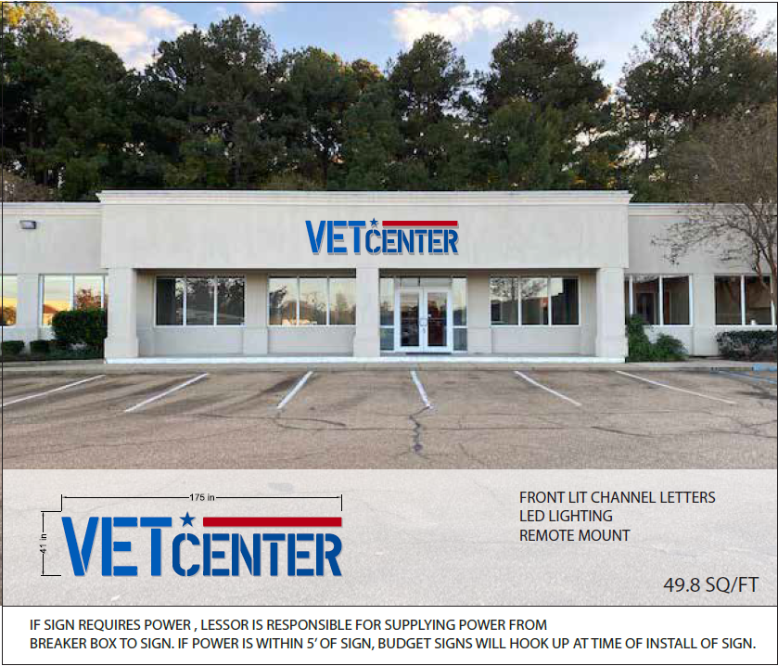

1. Main Entry Door Decal.
2. VA to approve sign design schematic prior to fabrication/installation.
3. Lessor shall provide signage on the main entrance door.
4. Font: Zilla Slab, Source Sans Pro. Approved alternatives include Rockwell or Arial.
5. Decal Information to include:

* Vet Center Brand/Logo
* Vet Center Name
* Vet Center Address
* Open Monday – Friday 8AM–4:30PM
* Ask about additional hours to meet your needs.
* Vet Center Office Phone Number
* Veterans Crisis Line Call 1-800-273-8255 and Press 1 to receive confidential support 24 hours a day.
* VA Seal

1. Signage Logo Scalable Vector ai. file and PNG. file is available/provided by VA.

* Main Entry Door Logo:



* VA Seal:

[Special Topic Criteria - Office of Construction & Facilities Management (va.gov)](https://www.cfm.va.gov/til/spclRqmts.asp#PS)

[SD101400-03.pdf (va.gov)](https://www.cfm.va.gov/til/sDetail/Div10Specialties/SD101400-03.pdf)

[Color Specifications for the Department of Veterans Affairs Seal (va.gov)](https://www.cfm.va.gov/til/etc/VASealColors.pdf)

1. Sample Illustration.

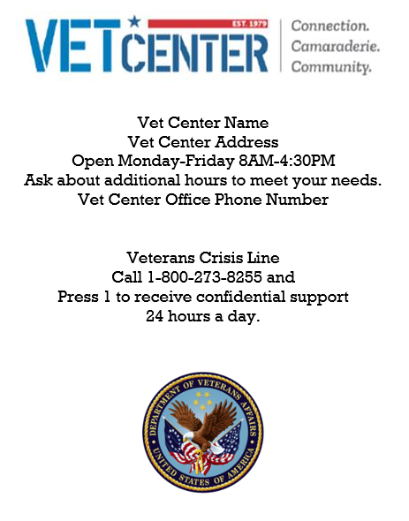

1. Entrance Signs.
2. Lessor shall provide the mandatory entrance signage. [VA Signage Design Guide](https://www.cfm.va.gov/til/signs/Signage07-Mandatory.pdf)
3. VA to approve sign design schematic prior to fabrication/installation.
4. No Smoking, IN-02.02, 18”-20”
5. No Weapons Permitted, IN-02.10, 6” x20”
6. Sample Illustration.

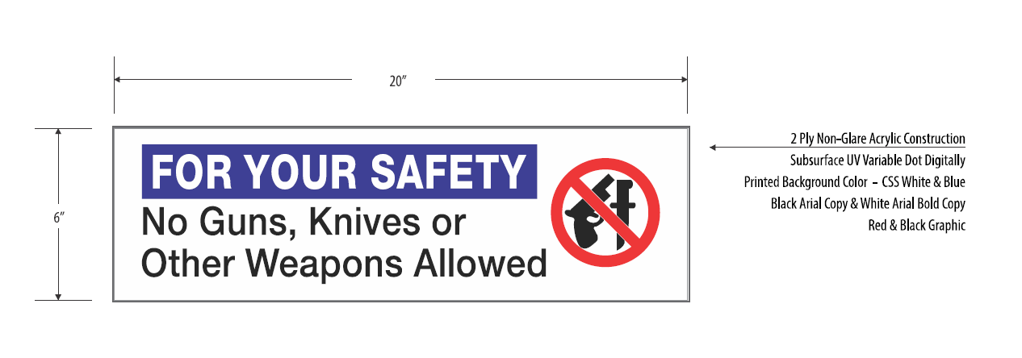 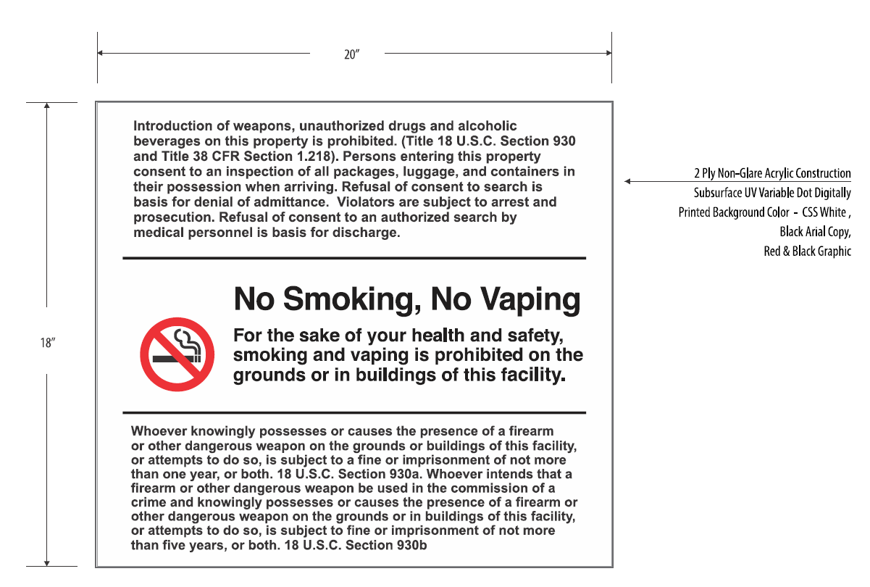

1. **EXHIBITS SECURITY:** Brand Name/Equal. Characteristics and level of quality that will satisfy the Government’s needs.
2. Closed Circuit Television System (CCTV) System.
3. S2 NetBox VR Quatro

[S2 NetBox VR Quatro | S2 Security (s2sys.com)](https://www.s2sys.com/solutions/products/access-control-systems/s2-netbox-vr-quatro)

100% Web user interface. Power, network drop, web browser are all the system requires. Single cabinet, stand-alone system.

1. Security Intrusion Alarm System.
2. BOSCH D7412GV4 Control Panel

[Bosch | D7412GV4 Control Panel | Control Panels and Keypads (boschsecurity.com)](https://commerce.boschsecurity.com/us/en/D7412GV4-Control-Panel/p/2495670155/)

1. BOSCH B920 2 Line Alpha Numeric Keypad (SDI2)

[Bosch | 2 Line Alpha Numeric Keypad (SDI2) | B920 (boschsecurity.com)](https://commerce.boschsecurity.com/us/en/2-Line-Alpha-Numeric-Keypad-SDI2/p/F.01U.385.668/)

1. Motion Sensors.
2. BOSCH Blue Line Gen2 TriTech Motion Detectors

[Bosch | Blue Line Gen2 TriTech Motion Detectors | Detectors and Accessories (boschsecurity.com)](https://commerce.boschsecurity.com/us/en/Blue-Line-Gen2-TriTech-Motion-Detectors/p/2612755083/)

1. Security Camera.
   1. AXIS P3245-V Network Camera, Streamlined and versatile HDTV 1080p fixed dome

[AXIS P3245-V Network Camera | Axis Communications](https://www.axis.com/products/axis-p3245-v)

1. Duress Alarm Button.
2. BOSCH EN1235F Series Fixed-location Transmitters

[EN1235F Series Fixed-location Transmitters (azureedge.net)](https://resources-boschsecurity-cdn.azureedge.net/public/documents/Data_sheet_enUS_2578290187.pdf)

1. Duress Alarm Button Wall Mount (restrooms)
2. Model PBL-1 Emergency Station

[MODEL PBL-1:CUTSHEET TEMPLATE.qxd (rackcdn.com)](http://3eccd697040ff376029e-37f4b5a5c64a33e4803457a28ff6ef21.r41.cf5.rackcdn.com/AC-PBL1-1.pdf)

1. C-Readers Physical Access (OIT)
2. HID ThinLine II Reader

prox-thinline-ii-reader-ds-en.pdf