**Performance Work Statement**

FY 23 STAND IMPROVEMENT– FINGER LAKES NATIONAL FOREST

**General Information**

It is the intent of this solicitation and any resulting contract to secure services for stand improvement (crop tree release (of both sapling and pole-sized stands) and mid-story removal).

**Item 0001** shall include mid-story removal (tree felling) and any resulting required slash disposal work.

**Item 0002** shall include crop tree release of pole-sized stands (tree felling) and any resulting required slash disposal work.

**Item 0003** shall include crop tree release of sapling-sized stands (tree felling) and any resulting required slash disposal work.

The Contractor shall furnish tools, labor, equipment, and supervision unless otherwise provided herein.

**Location and Description**

The project locations are on the Hector Ranger District of the Finger Lakes National Forest in Schuyler County, New York. Work locations will be shown on vicinity and unit specific maps.

**Item 0001**

These units are flagged with blue flagging. They are predominantly pole and sawtimber-sized hardwood-dominated stands that were commercial thinned in 2010.

**Item 0002**

These units are flagged with blue flagging. They are predominantly pole sized hardwood-dominated stands that were harvested around 1991.

**Item 0003**

These units are flagged with blue flagging. They are predominantly sapling-sized hardwood-dominated stands that were patch/group cuts harvested in 2010.

**Delivery Details/Period of Performance**

**Time of Performance**

The period of performance is July 1, 2023 through June 30, 2024. *Note timing restrictions on Items* ***0001AA.***

***0001AA – No cutting allowed April 1 – October 31st.***

**Work Progress Schedule**

Upon contract award, the Contractor shall be required to present a written plan of work providing for the orderly and timely completion of the contract requirements. This plan is subject to the approval of the Government. The plan should present when the Contractor intends to start and complete the bid items on each of the Districts and how many crews will be working at one time. The schedule may be modified during the course of the contract when conditions warrant if approved by the Government.

If the work progress falls behind schedule, the Contractor shall take such action as necessary to ensure that the timely completion of the contract is not jeopardized. In addition, the Contracting Officer may require the Contractor to submit a revised plan of work showing how they intend to complete the project on time and in compliance with all contract requirements.

**Definitions**

CROP TREE – Desirable tree left in the stand after SI activities. A crop tree is one that exhibits desirable characteristics that help meet management objectives, has the ability to respond to treatment and can remain competitive for many years.

CUT TREE – A tree according to the specifications defined in each item that shall be cut.

DBH (DIAMETER BREAST HEIGHT) – Diameter of the trunk of the tree measured at 4-1/2 feet above the ground level on the uphill side of the tree.

LEAVE TREE – Any tree that is required to be left standing as provided in the specifications.

LIVE CROWN RATIO – The ratio of living crown to a tree’s height, expressed in percent. See **Exhibit D**.

LOP AND SCATTER - To cut limbs from the trunks of cut trees, and move and rearrange slash concentrations to achieve a slash depth required in the contract.

POLE – A tree greater than 5 inches DBH and less than 10 inches DBH.

RELEASE – the act of freeing a young stand of desirable trees from competition of undesirable vegetation that suppresses or threatens to suppress them.

RELEASE (AREA) – Release thinning which removes competing crowns from crop and reserve trees (5 feet from three sides for pole-sized trees, and 5 feet from all sides for sapling-sized trees).

RESERVE TREE **–** A tree designated to be left.

SAPLING – A tree greater than 4.5 feet in height and less than 5 inches DBH.

SLASH **–** Limbs and trunks of downed trees.

SNAGS **–** standing dead trees.

SUBORDINATE – a tree adjacent to a crop tree where the crown does not extend above the midpoint of the crown of the crop tree.

TREE CROWN - the living branches of a tree.

**CONTRACTOR REQUIREMENTS**

**FELLING SPECIFICATIONS – ALL BID ITEMS**

The Contractor shall adhere to the following specifications for all projects involving tree felling unless there are specific supplemental specifications:

* No trees outside designated unit boundary shall be cut
* No trees exceeding 10.0 inches DBH shall be cut unless specified otherwise.
* No property or item boundary trees marked with paint or flagging shall be cut.
* All snags shall be left unless required to fall for safety concerns.
* Apple, oak, butternut, chestnut, mountain ash, hawthorn, American and hop hornbeam, and serviceberry (shadbush) if present shall not be cut.
* Trees that cannot be felled without crossing a property line should be girdled and left standing. Trees shall be directionally felled away from fence lines.
* All treated stumps shall not exceed 12 inches in height above ground and shall be cut below the lowest live limb unless obstructed by natural obstacles. If stem is obstructed by natural obstacles, then stumps shall be cut to a maximum of 4 inches above these obstacles.
* Trees in sprouts (multiple stems) will be cut as close to the ground as possible.
* Trees required to be cut shall be completely severed from the stump.
* The cut angle of stumps shall be cut level (not to exceed 20 percent from horizontal).
* No cut trees shall be suspended above the ground. No tops shall be left hanging in standing trees.
* Cut trees that are hung up above ground shall be cut or pulled down. NO CUT TREES THAT ARE HUNG UP WILL BE ACCEPTED. ALL CUT TREES MUST BE ON THE GROUND REGARDLESS OF THE AMOUNT OF BUCKING/LIMBING REQUIRED.
* Annuals such as grasses, sedges, ferns, are not required to be cut.
* Trees for cutting will be felled with axe, chainsaw or brush saw.
* Contractor will exercise caution and care in all operations to minimize damage to leave trees.
* Contractor shall not cut any trees that have bird nests in them.
* In Items 0001 and 0003, Morrow Honeysuckle and Common Buckthorn over 0.5” DBH shall be cut in each subitem.

**SLASH REQUIREMENTS – ALL BID ITEMS**

The Contractor shall adhere to the following specifications for ALL BID ITEMS involving slash disposal unless there are specific supplemental specifications:

* Slash created by the contractor's operation shall be removed from road surfaces, fence lines, ditches, trails, power lines, culverts, and stream courses.
* In units that are adjacent to private land that appear on subitem maps, lop and scatter slash within 25 feet of private land boundary. If trees are accidentally felled into private land, the boles and slash must be removed and placed back into the contract unit
* Slash shall be pulled back 15 feet from the edge of “Local roads” that appear on subitem maps, within 100 feet of roads slash must be lopped and scattered to a height no greater than 2 feet off the ground.
* No slash may be left hanging in trees. All cut trees must be on the ground regardless of how much bucking/limbing must occur.

**Item Supplemental Specifications**

**Item 0001 – Mid-Story Removal**

The contractor shall cut all trees between 2” and 10” DBH meeting the criteria of a cut tree:

* Cut trees are:

1. All tree species not listed as a reserve tree.

* Reserve trees are: white oak, red oak, chestnut oak, black oak, hickory, basswood, white pine, red spruce, butternut, American chestnut, white ash, American beech free of beech bark disease, witch hazel, hawthorn, blue beech.

**Item 0002 –Crop Tree Release (Pole timber)**

The Contractor shall release all available crop trees (up to 40 trees per acre), by felling cut trees based on the following criteria.

**Selection of Crop Trees:**

* Crop trees will be trees that:
  1. are relatively straight stemmed,
  2. have well-developed crowns (evenly distributed around the circumference, live crown ratios exceeding 30 percent [**Exhibit** D]),
  3. have no low forks or heavy branching within the bottom 10 feet.
  4. be healthy and vigorous with no disease or decay visible. Minimal defect that has healed or is healing is acceptable
  5. and be at least equal to, or nearly equal to the height of surrounding trees (**Exhibit** C).
* Crop trees are reserve trees and shall not be cut.
* Crop tree species preference is as follows (trees are listed in order of higher preference): white oak, chestnut oak, red oak/black oak, hickory, sugar maple, red maple. No other species should be considered crop trees.

**Cutting of Cut Trees:**

* Cut trees are:

1. In contact with the canopy of the crop tree
2. Approximately equal to or greater than in height of the crop tree
3. And 1-8” DBH

* The crown of the crop trees will be released for a radius of five feet on at least 3 sides (**Exhibit** A and **Exhibit** B).
* Grape vines growing on the crown of a crop trees will be severed.
* Trees that meet the criteria of a crop tree shall not be cut

**Item 0003 –Crop Tree Release (Sapling)**

The contractor shall release all white oak, chestnut oak, red oak, black oak, and hickory of good form and health (up to 100 trees per acre), by felling cut trees that meet the criteria below.

**Selection of Crop Trees:**

* Crop trees will be trees that:

1. are relatively straight-stemmed,
2. be healthy and vigorous with no disease or decay visible. Minimal defect that has healed or is healing is acceptable

* Crop trees are reserve trees and shall not be cut.
* Crop tree species preference is as follows (trees are listed in order of higher preference): white oak, chestnut oak, red oak/black oak, hickory. No other species should be considered crop trees.

**Cutting of Cut Trees:**

* Cut trees are:

1. In contact with or within five feet of the crown of a sapling species listed above
2. And 1-6” DBH

* Trees that meet the criteria of a crop tree shall not be cut

**Contractor’s Key Personnel**

The Contractor’s onsite representative shall be fully conversant in the English language, spokenand written, sufficient to read and understand the contract, and communicate effectively with the COR.

The Contractor’s employees performing felling shall be able to identify commercial and non-commercial hardwoods and conifers, common diseases and decay present in northern hardwood stands, and be able to identify suitable crop trees per the definitions in this contract.

**Special Requirements**

**Items: *0001AA – No cutting allowed April 1 – October 31st.***

**ATV/UTV Access -** Access to treatment units on OM Level 1 roads using All Terrain Vehicles (ATV) or Utility Terrain Vehicles (UTV) less than 50 inches wide may be granted upon request. ATV or UTV equipment shall be made available for inspection to the COR prior to first use on the Green Mountain National Forest, and subsequently each time it leaves the Green Mountain National Forest and is returned. ATV or UTV equipment will only be allowed access on OM Level 1 roads if it is free of dirt and vegetative debris. OM Level 1 roads are indicated on item maps.

**Refueling Away from Streams, Wetlands** – Avoid refueling chainsaws and other motorized equipment within 100 feet of streams and wetlands that appear on Subitem maps.

**Signage** – Signs will be used where crews are working near a road, trail, or other feature in which the public may be present. Signs should read “Tree Work Ahead” or equivalent and be 36” x 36” in size.

**Nests** - Should a nest be found in any unit of the contract items, at any time during the contract term, the contractor shall flag the tree and write “nest” on the flagging and shall not cut the tree. Additionally, if the nest exceeds 1 foot in diameter or a raptor is observed using the nest the contractor shall immediately stop work in the unit, take a GPS point at the location the nest or where the raptor was observed and notify the COR.

**Notification** - Contractor is required to notify the COR prior to starting work on any item. The contractor shall also notify the Contracting Officer at least monthly of the progress being attained on this project. This notification can be either oral or written.

**Measurement -** Method of Measurement, area computation was done with a hand held GPS unit used for locatingtimber sale units or stands.Re-measurement - Request for re-measurement must be in writing. If a re-measurement indicatesa variance greater than + or - 10 percent, the Government will pay for the re-measurement andpayment for the work made on the basis of the re-measurement. If re-measurement shows avariance within + or - 10 percent of the predetermined acres, the cost of the re-measurement will bededucted from the contract amount.

**Safety Equipment and Operations -** Contractors must comply with all OSHA standards related to contract work. Failure to use proper personal safety equipment or non-compliance with safe operating procedures, as outlined byOSHA, will result in a work stoppage.

**Road Use and Maintenance -** All roads leading into each project area to be worked are to be kept open and free of any debris thatmay occur as a result of the work.All existing roads used by the Contractor shall be left in the same condition, or better, as when the operation started.Prior to the start of work, the Contractor and COR will review and document existing roadconditions to provide a basis for maintenance needs.

**Quality Control Plan –** Contractors must develop and follow a quality control plan to monitor and document the performance of their own work. Measures monitored and documented in the quality control plan should follow the performance requirement measures and all special requirements. Quality Control Plan monitoring documentation shall be made available to the COR at the request of the COR.

**Performance Requirement Measures**

The COR or inspector will make visual inspections of each project area to check for compliance with contract specifications. The COR may make random or periodic inspections. In addition to the Special Requirements section, the following items will be considered as being in non-compliance:

* Specified trees cut: 95% of work accomplished for each item should include all specified trees cut as specified.
* Slash treatment not complete: 95% of completed work for each item should include proper treatment.
* Stump height and criteria: 95% of completed work in each item shall exhibit stumps of the heights and criteria as specified in the specifications.
* Selection and Protection of reserve or crop trees: 95% of completed work in each item shall exhibit only the specified items cut, 95% of suitable crop trees selected and released.

For work under each item that is not in compliance with the performance thresholds and cannot be reworked a 2% disincentive will be subtracted from the total value of the item.

**Supplemental Exhibits** (reproduced from Miller et al 2007, Technical Guide to Crop Tree Release In Hardwood Forests, 2010 FIA Field Guide):

**Exhibit A.** Crop Tree Release Above View:

 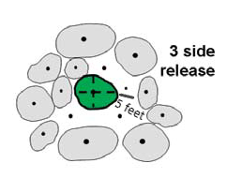

Before: After: “3 Side Release” (5 feet min. release distance)

**Exhibit B**. Crop Tree Release – Side View:

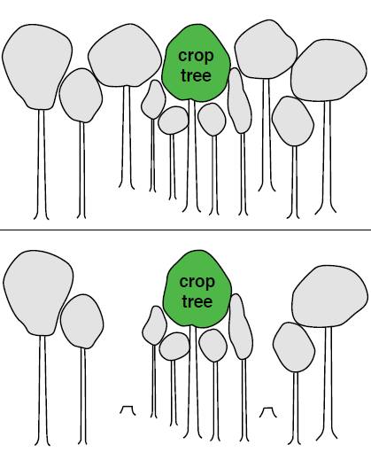

Canopy Side View After Crop Tree Release **Note: subordinate trees have not been cut.**

Canopy Side View Before Crop Tree Release

**Exhibit C.** Canopy position of Crop Tree and Cut tree for Crop Tree Release

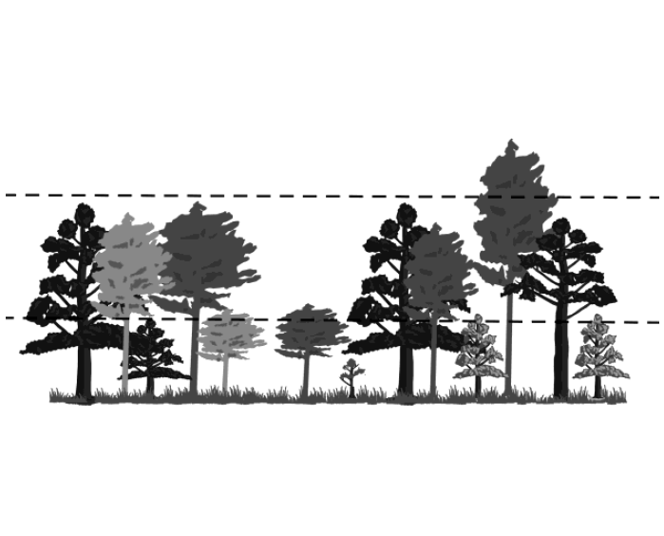

Canopy position **not** suited for crop tree or cut tree

Canopy position **not** suited for crop tree

Canopy position of Suitable Crop Tree

**Exhibit D.** Live Crown Ratio



Live crown ratio = (x/y * 100), minimum of 30 required for crop trees.